# VPC TASK

1. Create one VPC, with 1 one public subnet and 1 private subnet.

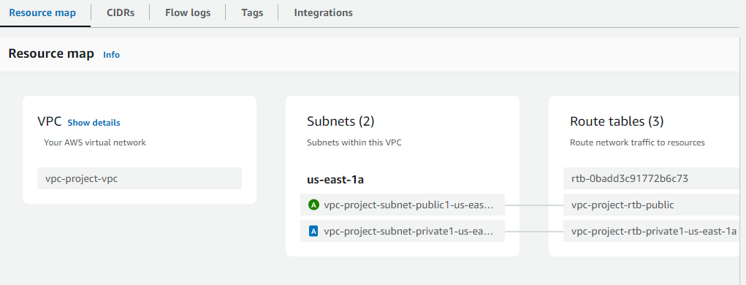

1. Enable VPC peering for cross region.

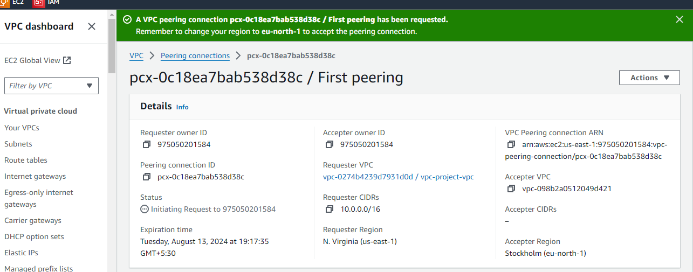

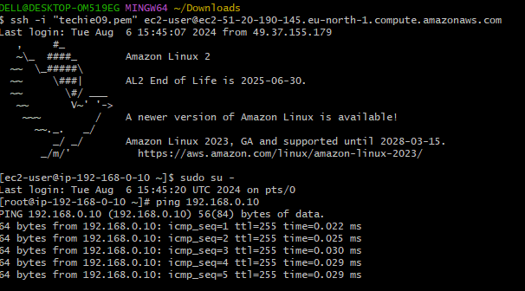

1. Enable VPC peering for cross account.

